Login to AWS

You have a separate AIM user with admin privileges to access our infrastructure.

Login: mShaghelani

Account ID: 910082668725

Password will be sent to you

Accessing EC2 Instances

1. Firstly, you will have to click on EC2 link which you can find here

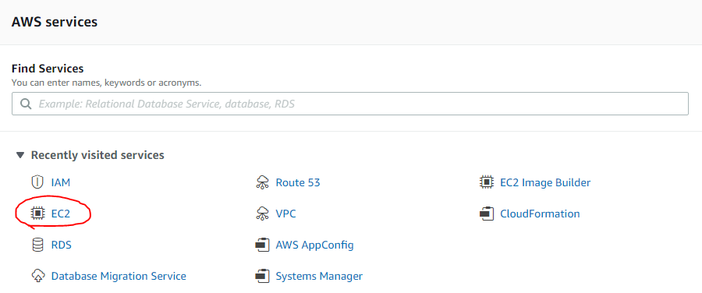

1. After accessing the EC2 service you will notice 2 launched instances with appropriate names



* Backend contains Apache2 + Flask
* Frontend contains Apache2 plain

1. There are 2 ways of connecting to instances via SSH
   1. Service Manager

Simply click on the instance, click connect and you will be prompted with the session manager window

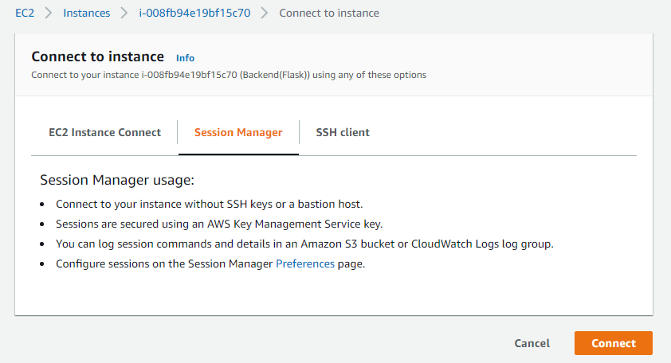

* 1. Using SSH client

For Linux issue this command: ssh -i "myKeyPair.pem <public ip of server>

For Windows (SSH clients) credentials will be provided in the end of the documents

Credentials

Frontend(Apache2 plain):

* Public IP: 3.125.153.90
* Private IP: 172.31.8.208
* Public DNS:  ec2-3-125-153-90.eu-central-1.compute.amazonaws.com
* Private DNS: ip-172-31-8-208.eu-central-1.compute.internal

Backend(Apache2+Flask):

* Public IP: 18.184.24.215
* Private IP: 172.31.13.172
* Public DNS:  ec2-18-184-24-215.eu-central-1.compute.amazonaws.com
* Private DNS: ip-172-31-13-172.eu-central-1.compute.internal

*PEM key for connection and password for IAM user will be sent by your request due to security constrains!*